**Assignment 4 | 25th January 2021**

***Question 1***

**By how many ways we can access elements in the DOM and write about them in brief?**

**Ans :**  There are 5 ways to access HTML elements in the DOM — by ID, by class, by HTML tag name, and by selector

Day_4.Js code :

var ele=document.getElementsByClassName("age");

console.log(ele[1].innerText);

var ele1=document.getElementById("demoId");

console.log(ele1.innerText);

var ele2=document.getElementsByTagName("demoTag");

console.log(ele2);

var ele4=document.querySelector("p.demoSelector");

console.log(ele4.innerText);

var ele5=document.querySelectorAll("p.demoSelectorAll");

console.log(ele5[0].innerText);

console.log(ele5[1].innerText);

***Question 2***

**Write a JavaScript program that will take 2 numbers from the HTML page and display them on the**

**HTML page after the addition of those 2 numbers.**

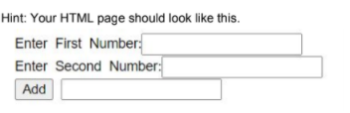

**Day_4.html code:-**

<div>

            Enter First Number :

            <input type="number" id="first" /><br>

            Enter Second Number :

            <input type="number" id="second"/><br>

            <input type="submit" onclick="add()" value="Add"/>

            <input type="text" id="Ans"/>

        </div>

**Day_4.js code:**

function add(){

    var a,b,c;

    a=parseInt(document.getElementById("first").value);

    b=parseInt(document.getElementById("second").value);

    c= a + b;

    document.getElementById("Ans").value= c;

};

**Output :**

